Group 1- Using ProDiscover

Connor Crossen and Blake Newland

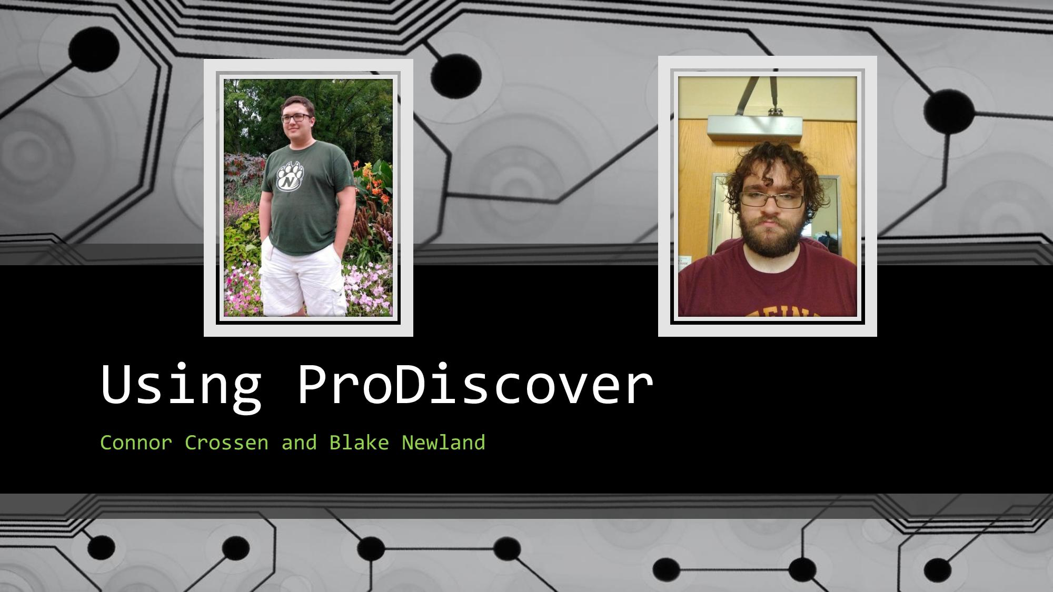

Here is a link to our workshop repo so far. Last minute tweaks and preparations are still in progress, so some changes may occur before the actual presentation.

<https://github.com/cncrossen/prodiscover-workshop>

Here is the email that will be sent out to the class this evening:

“All,

Please do the following in preparation for the ProDiscover workshop tomorrow during class:

1. Verify your installation of ProDiscover basic is still functional
2. Bring a USB drive or other drive to class (this drive will be made into an image file using ProDiscover- the less files it has, the quicker it will be!)

Best,

Group 1”